CS 4398

Spring 2019

Software Requirements Specification

Gus’s fried chicken Online ordering system

Chris diaz, john daloni, gese rocha, zach stence

**Table of Contents**

**1. Preface**

1.1 Purpose

1.2 Document Conventions

1.3 Intended Audience

1.4 Proposed Product Scope

1.5 References

**2. Overall Description**

2.1 Product Perspective

2.2 Product Functions

2.3 User Characteristics

2.4 End-User Operating Environment

2.5 Design and Implementation Constraints

**3. Functional Requirements**

3.1 Inventory Management System

3.1.1 Use Case 1: Employee Login

3.1.2 Use Case 2: View Restaurant Inventory

3.1.3 Use Case 3: View Inventory History

3.1.4 Use Case 4: New Employee Account

3.2 Order Management System

3.2.1 Use Case 1: Employee Login

3.2.2 Use Case 2: View Restaurant Inventory

3.2.3 Use Case 3: Edit Restaurant Inventory

3.2.4 Use Case 4: View Order History

3.2.5 Use Case 5: View Open Orders

3.2.6 Use Case 6: Make Customer Transaction

3.2.7 Use Case 7: View Transaction Record

3.2.8 Use Case 8: Edit Customer Order

3.2.9 Use Case 9: Complete Order

3.2.10 Use Case 10: Create Customer Account

3.2.11 Use Case 11: View Customer Accounts

3.2.12 Use Case 12: View Menu

3.2.13 Use Case 13: Apply Coupon/Credit

3.3 Customer Order System

3.3.1 Use Case 1: Customer Login

3.3.2 Use Case 2: Create Customer Account

3.3.3 Use Case 3: Edit Account Details

3.3.4 Use Case 4: View Menu

3.3.5 Use Case 5: Order Item

3.3.6 Use Case 6: View Basket

3.3.7 Use Case 7: Edit Basket

3.3.8 Use Case 8: Checkout

3.3.9 Use Case 9: Payment

**4. Non-Functional Requirements**

4.1 Reliability

4.2 Robustness

4.3 Performance

4.4 Maintainability

4.5 Usability

4.6 Security

**1. Preface**

**1.1 Purpose**

The purpose of this document is to provide a detailed overview of Gus’s Fried Chicken Online Ordering System, as well as its parameters and goals. This document will also explain the features and purpose of Gus’s Fried Chicken Online Ordering System. This site shall be a reliable system that provides the user a simple interface to make orders, employees to manage orders, and employees to manage inventory. This version of the product is 1.0 and this SRS shall cover the scope of Gus’s Fried Chicken Online Ordering System.

**1.2 Document Conventions**

|  |  |
| --- | --- |
| UI | User Interface |
| The site/system | Gus’s Fried Chicken Online Ordering System |
| Basket | Shopping Cart |

**1.3 Intended Audience**

This document is to be read by fans and employees of the restaurant, as well as by the developers making the site. The goal of the site is to create a smooth and easy way to place online orders, create profiles, and manage kitchen inventory.

**1.4 Proposed Product Scope**

This requirements document provides information about the software system designed for the restaurant. The software system designed will have the following subsystems:

* Inventory Management: Allows employees to keep track of, and edit ingredient and item quantity in kitchen.
* Employee Order Management System: Allows employees to handle tasks related to viewing, billing, and processing orders.
* Customer Order System: To provide a way for customers to order food online.

**1.5 References**

“MVC Design Pattern.” *GeeksforGeeks*, 8 Feb. 2018, www.geeksforgeeks.org/mvc-design-pattern/.

**2. Overall Description**

**2.1 Product Perspective**

This system is s being developed for the CS-4398 class at Texas State University. The software is a new, self-contained product and will be set for release in Spring 2019.

**2.2 Product Functions**

This software will be a web based application, hosted in the cloud. The software shall provide the following major functions to the user(s) operating it:

* Inventory Management: Employee Login, View Restaurant Inventory, Edit Restaurant Inventory
* Employee Order Management System: Employee Login, View Restaurant Inventory, Edit Restaurant Inventory, View Order History, View Open Orders, Make Customer Transaction, View Transaction Record, Edit Customer Order, Complete Order, Create Customer Account, View Customer Accounts, View Menu, Apply Coupon/Credit
* Customer Order System: Customer Login, Create Customer Account, Edit Account Details, View Menu, Order Item, View Basket, Edit Basket, Checkout

**2.3 User Characteristics**

The software system designed for the restaurant is designed with both

the employees and customers in mind. The system is designed so that these users will be able to easily use and navigate the software.

**2.4 End-User Operating Environment**

The software system designed is will have a user interface acceptable over the internet. Internet access along with mouse, keyboard, and computer use will be required. Users can access from anywhere.

**2.5 Design and Implementation Constraints**

The software will use multiple programming languages during its development. C#, SQL, HTML, CSS, and JavaScript will all be used to create the user interface, backend, and database. The design of the website will utilize a Model-View-Controller design pattern. The system will be hosted using cloud solutions.

**3. Functional Requirements**

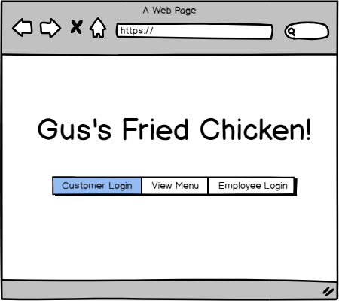

**3.1 Inventory Management System**

**3.1.1 Use Case 1: Employee Login**

Cleared employees with inventory management access will be able to log in to the website to access the inventory management system.

**3.1.2 Use Case 2: View Restaurant Inventory**

Logged in employees will be able to view current inventory of the kitchen. This inventory will be associated with what is available to order.

**3.1.3 Use Case 3: Edit Restaurant Inventory**

Logged in employees will be able to edit the current inventory, in order to accurately keep track of what is and isn’t in stock, update after deliveries, and correct any inventory errors.

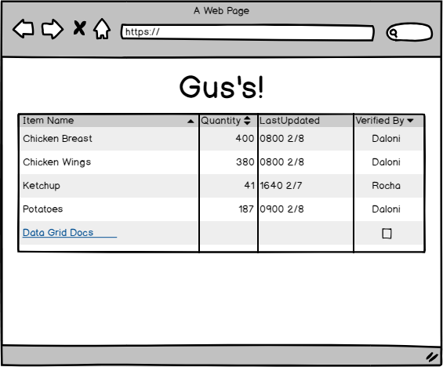

**3.1.4 Use Case 4: New Employee Account**

New employees will be able to have an account created for them by another employee. This enforces an external layer of security to operation and use of the employee side of the software.

**3.2 Order Management System**

**3.2.1 Use Case 1: Employee Login**

Employees will be able to log in to the order management system. Requiring a login to manage orders enforces accountability in keeping track of what employee handles which order.

**3.2.2 Use Case 2: View Restaurant Inventory**

All employees will be able to view restaurant inventory, though only some will be able to edit it. This read only mode for most employees will minimize accidental errors in inventory.

**3.2.3 Use Case 3: Edit Restaurant Inventory**

Cleared employees with inventory management access will be able to log in to the website to access the inventory management system. By allowing only a few employees such as management inventory control access, this prevents inventory management errors.

**3.2.4 Use Case 4: View Order History**

Employees will be able to view the history of orders. This will allow management to look for trends over specific periods of time, and perform data analysis as needed.

**3.2.5 Use Case 5: View Open Orders**

Employees will be able to view currently open orders that are awaiting fulfillment, and will be able to see certain details such as order time, desired pickup time, customer name, the order, and additional comments.

**3.2.6 Use Case 6: Make Customer Transaction**

For customers that did not pay online, employees will be able charge a customer for an order and create a bill.

**3.2.7 Use Case 7: View Transaction Record**

Employees will be able to view past and completed transactions for that day.

**3.2.8 Use Case 8: Edit Customer Order**

Employees will be able to edit orders made by customers, in case something needs to be changed or corrected.

**3.2.9 Use Case 9: Complete Order**

Employees will be able to close out a customer order, marking it as complete.

**3.2.10 Use Case 10: Create Customer Account**

Employees will be able to help new customers create an account to save ordering information.

**3.2.11 Use Case 11: View Customer Accounts**

Employees will be able to view a customer’s account information.

**3.2.12 Use Case 12: View Menu**

Employees will be able to view the menu, and even place an order for customers over the phone if customers need assistance.

**3.2.13 Use Case 13: Apply Coupon/Credit**

Employees will be able to apply coupons, gift cards or other forms of credit or discounts to a customer’s order.

**3.3 Customer Order System**

**3.3.1 Use Case 1: Customer Login**

Customers will be able to login to their own saved account, for faster checkout. Customers can also skip this if they would prefer to checkout as a guest.

**3.3.2 Use Case 2: Create Customer Account**

Customers will be able to create a new account in order to save information for fast checkouts. This will include favorite meals, store credit storage, and customer contact information.

**3.3.3 Use Case 3: Edit Account Details**

Customers will be able to view and edit their account details, in order to correct any errors, or update their information.

**3.3.4 Use Case 4: View Menu**

Customers will be able to view the restaurant menu, and see if items are available to order. The menu will reflect the current seasonal offerings of the restaurant.

**3.3.5 Use Case 5: Order Item**

Customers will be able to add menu items to their cart, and prepare an order. Customers will have the option to make comments in their basket if their order requires special handling. Items available for order will be associated with the current inventory.

**3.3.6 Use Case 6: View Basket**

Customers will be able to view their basket, and see what items they have selected for order before checking out.

**3.3.7 Use Case 7: Edit Basket**

Customers will be able to edit the items in their basket, increasing or decreasing desired quantities as needed.

**3.3.8 Use Case 8: Checkout**

Customers will be able to enter a checkout process in order to submit their order. Here they can add any final comments they wish the restaurant staff to know.

**3.3.9 Use Case 9: Payment**

Customers will be able to pay online using PayPal if they wish, or alternatively pay in store during pickup.

**4. Non-Functional Requirements**

**4.1 Reliability**

The web application shall run smoothly without crashes, bugs, or downtime. Response time shall be relatively quick from the system after each user action so there is minimal delay for the response from the system. High quality system and database hosting will be important to ensure reliability.

**4.2 Robustness**

There are a few main points of failure in the restaurant software system, the largest of which is the interactions with the storing and retrieval of data from the database. If network connection is lost, stored and requested data may be incomplete or lost by the system. To increase reliability, cloud based solutions will be utilized.

**4.3 Performance**

A major bottleneck in performance is payment processing, and handling orders during high volume hours. To address these issues and speed up transaction time, our software will third party payment processing, and elastic hosting from cloud solutions. Gift cards will be treated as store credit to the customer’s account. When a purchase is made and the customer indicated gift certificate, the funds are automatically subtracted from the customers store credit eliminating the need to request and enter the customer’s payment information. An elastic cloud service will be able to instantly scale content delivery and processing in accordance with user demand.

**4.4 Maintainability**

The system will be stored and run with a cloud services provider. This will allow easy maintenance after being setup, as hardware care will be outsourced to a 3rd party. The hosting service will elastic processing, storage, and delivery power to scale as needed with customer demand.

**4.5 Usability**

To maximize performance of the staff, the GUI of this software will be image and icon based so navigation is intuitive. From the landing page, visitors will be able to login to use advanced functionality, or browse public information at their leisure. After logging in, each function is streamlined to direct the employee to each necessary piece of information and function needed to manage orders and inventory, while customers will have different options to create and make an order.

**4.6 Security**

Our web application will be handling sensitive customer information during transactions. To begin, all traffic will be done exclusively over https for secure, encrypted communications. No customer data will be stored locally on any device, but will be stored securely using the cloud provider’s secure storage. Customers who wish to pay online will be encouraged to use payment solutions such as PayPal, AmazonPay, GooglePay, or ApplePay in order to avoid ever having to use sensitive credit card information.